#include <stdio.h>
int a = 1;
int count = 3;
int arr[28];
int i = 0;
int pos, num, temp;

void insert();
void del();
void display();

void main()
{
printf("Enter the numbers\n");
for (int i = 0; i<count; i++){
scanf("%d", &arr[i]);
}
while (a>0)
{
printf("1-Insert\n2-Delete\n3-Display\n4-Exit\n");
scanf("%d", &i);
switch(i)
{
case 1:
insert();
break;
case 2:
del();
break;
case 3:
display();
break;
case 4:
printf("Exit\n");
return;
default:
printf("Invalid Choice\n");
}
}
}
void insert(){
printf("Insert\n");
printf("Enter the number: ");
scanf("%d", &num);
printf("Enter the position: ");
scanf("%d", &pos);
count += 1;
if (pos < 0 || pos > count)
{
printf("Error");
return;
}
temp = arr[pos];
arr[pos] = num;
for(int i = pos; i < count; i++)
{
int xyz = arr[i+1];
arr[i+1] = temp;
temp = xyz;
}
}
void del()
{
printf("Delete\n");
printf("Enter the position: ");
scanf("%d", &pos);
count -= 1;
for (int i = pos; i<count;i++)
{
arr[i] = arr[i+1];
}
}
void display()
{
printf("Display\n");
for(int i = 0;i < count; i++)
{
printf("%d, ", arr[i]);
}
printf("\n");
}
Insertion
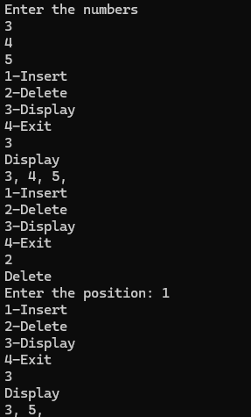

Deletion
